# Problem Statement

How to explain the concept of perceptron to non-AI students.

# Questions

## What is perceptron?

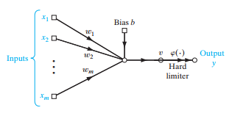  
Perceptron is the simplest form of a neural network used for classification process of patterns that are said to be linearly separable. Basically, it consists of a single neuron with adjustable weightage and bias.

## Who invented perceptron?

Frank Rosenblatt  
American psychologist  
Developed the algorithm used to adjust the free parameters of this neural network  
Constructed the hardware perceptron -> Mark I Perceptron (1960)  
Based on biological principles and showed ability to learn

## When perceptron is invented?

1943 (Idea of neural network) by McCulloch and Pitts

1949 (First rule of self-organized learning) by Hebb

1957 (Software)

1960 (Hardware)

## How to apply perceptron?

Rosenblatt demonstrated the ability to do image recognition

## Why use perceptron?

Advantages / Why create perceptron -> Machine learning

# Data Gathered

<https://www.pearsonhighered.com/assets/samplechapter/0/1/3/1/0131471392.pdf>

<https://en.wikipedia.org/wiki/Perceptron>

# Analysis of Data